**MEERUT INSTITUTE OF ENGINEERING AND TECHNOLOGY**

Session: 2022-2023

# MINI PROJECT REPORT

**On**

# “BOOK MY BUS”

**BACHELOR OF TECHNOLOGY IN COMPUTER**

**SCIENCE & ENGINEERING**

**(ARTIFICIAL INTELLGENCE & MACHINE LEARNING)**

## Submitted to- AJAY SHAH

**Department of Computer Science & Engineering**

**(Artificial Intelligence & Machine Learning)**

## Submitted by-

## HARSH KAUSHIK 2100681530022 3rd SEM

**VINAYAK CHAUHAN 2100681530059 3rd SEM**

**DEPARTMENT OF COMPUTER**

**SCIENCE & ENGINEERING**

**(Artificial Intelligence & Machine Learning)**

**MEERUT INSTITUTE OF ENGINEERING AND TECHNOLOGY, MEERUT**

## DECLARATION

We hereby declare that the project entitled -**“**BOOK MY BUS**”**, which is being submitted as Mini Project in department of Computer Science & Engineering (Artificial Intelligence & Machine Learning) to Meerut Institute of Engineering & Technology, Meerut (U.P.) is an authentic record of our genuine work done under the guidance of **“**AJAY SHAH**”,** Prof./ Assoc. Prof./ Asst. Prof. of Computer Science & Engineering (Artificial Intelligence & Machine Learning), Meerut Institute of Engineering and Technology, Meerut.

Date: 30/12/22 Name of students

HARSH KAUSHIK

VINAYAK CHAUHAN

Place:

MEERUT INSTITUTEOF ENGINEERING AND TECHNOLOGY

MEERUT

**CERTIFICATE**

This is to certify that mini project report entitled **– “**BOOK MY BUS**”** submitted by **“**HARSH KAUSHIK AND VINAYAK CHAUHAN**”** has been carried out under the guidance of **“**AJAY SHA**”,** .Asst. Prof. of Computer Science & Engineering (Artificial Intelligence & Machine Learning), Meerut Institute of Engineering and Technology, Meerut.

This project report is approved for Mini Project (KCS 354) in 3rd semester in Computer Science & Engineering (Artificial Intelligence & Machine Learning) from Meerut Institute of Engineering and Technology, Meerut.

**Internal Examiner**

**Date: 30/12/22**

## ACKNOWLEDGEMENT

I express my sincere indebtedness towards our guide **“**AJAY SHAH”, Prof./ Assoc. Prof./ Asst. Prof. of Computer Science & Engineering (Artificial Intelligence & Machine Learning), Meerut Institute of Engineering and Technology, Meerut for his valuable suggestion, guidance and supervision throughout the work. Without his kind patronage and guidance the project would not have taken shape. I would also like to express my gratitude and sincere regards for his kind approval of the project, time to time counseling and advises.

I would also like to thank to our HoD Dr. Rambir Singh, Department of Computer Science & engineering (Artificial Intelligence & Machine Learning), Meerut Institute of Engineering and Technology, Meerut for his expert advice and counseling from time to time.

I owe sincere thanks to all the faculty members in the department of Computer Science & engineering (Artificial Intelligence & Machine Learning) for their kind guidance and encouragement time to time.

Date: 30/12/22 Student name :

HARSH KAUSHIK

VINAYAK CHAUHAN

### Table of contents

**Description page no.**

**Declaration i**

**Certificate ii**

**Acknowledgement iii**

**Chapter 1 Introduction**

**Chapter 2 System Design**

(Work flow/flow chart/DFD/ working principle/ constructional details of individual components)

**Chapter 3 Technology Bucket**

3.1 Description of HTML

3.3 Description of CSS

**Chapter 4** Output screens

**Appendices** Implementation code

**References**  IEEE Format

**INTRODUCTION**

Unless like in the previous stage people as to walk into travel agency company to buy the tickets and also to check the timings. This problem is overcome introducing Online Ticket Booking System. This project will provide an option to customers to book the tickets online and to check the confirmation online. Using this system customer can book flight tickets, Bus tickets, Train tickets.

The application is reduced as much as possible to avoid errors while entering the data. It also provides error message while entering invalid data. No formal knowledge is needed for the user to use this system. Thus by this all it proves it is user-friendly. Online Bus Booking System , as described above, can lead to error free, secure, reliable and fast management system. It can assist the user to concentrate on their other activities rather to concentrate on the record keeping. Thus it will help organization in better utilization of resources.

The Bus ticket reservation system is currently maintaining the project Transport Company’s process manually which is a very time consuming process. It deals with transport industry’s ticket booking and transport maintenance, so it becomes a very tedious job for the ticket booking transporter to look after these particulars to complete the task at right time. The bus ticket booking system not only deals with transporters owned vehicles but also takes into consideration about the other types project of system transport vehicles available with other transporters.

The main objective of the Bus Ticket Booking System is to manage the details of Bus, Ticket, Booking, Agent, Seats. It manages all the information about Bus, Customer, Seats, Bus. The project is totally built at administrative end and thus only the administrator is guaranteed the access. The purpose of the project is to build an application program to reduce the manual work for managing the Bus, Ticket, Customer, Booking. It tracks all the details about the Booking, Agent, Seats.

**SYSTEM DESIGN**

In this system user searches the location from where he/she have to go and where to go. After Submit user is free to choose bus according to his/her choice.

**FLOW CHART**

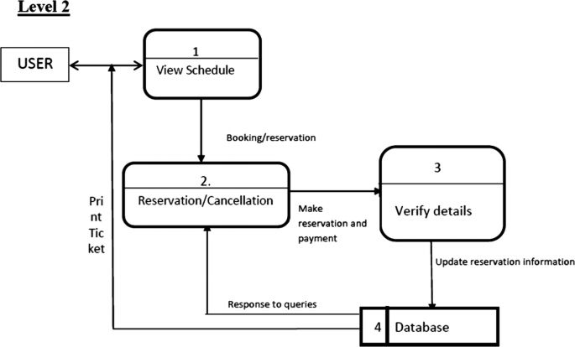

**TECHNOLOGY BUCKET**

**HTML**

HTML is an acronym which stands for **Hyper Text Markup Language** which is used for creating web pages and web applications. Let's see what is meant by Hypertext Markup Language, and Web page.

**Hyper Text:** HyperText simply means "Text within Text." A text has a link within it, is a hypertext. Whenever you click on a link which brings you to a new webpage, you have clicked on a hypertext. HyperText is a way to link two or more web pages (HTML documents) with each other.

**Markup language:** A markup language is a computer language that is used to apply layout and formatting conventions to a text document. Markup language makes text more interactive and dynamic. It can turn text into images, tables, links, etc.

**Web Page:** A web page is a document which is commonly written in HTML and translated by a web browser. A web page can be identified by entering an URL. A Web page can be of the static or dynamic type. **With the help of HTML only, we can create static web pages.**

**CSS**

CSS stands for Cascading Style Sheets. It is a style sheet language which is used to describe the look and formatting of a document written in markup language. It provides an additional feature to HTML. It is generally used with HTML to change the style of web pages and user interfaces. It can also be used with any kind of XML documents including plain XML, SVG and XUL.

CSS is used along with HTML and JavaScript in most websites to create user interfaces for web applications and user interfaces for many mobile applications.

Cascading Style Sheet (CSS) is used to set the style in web pages that contain HTML elements. It sets the background color, font-size, font-family, color etc property of elements on a web page.   
There are three types of CSS which are given below: 

* Inline CSS
* Internal or Embedded CSS
* External CSS

**OUTPUT SCREENS**

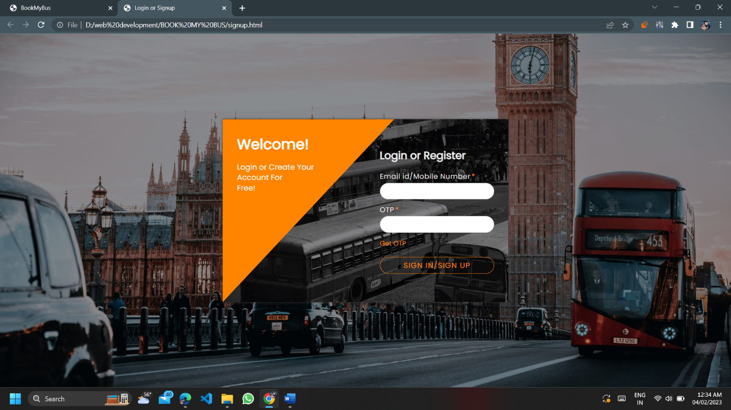

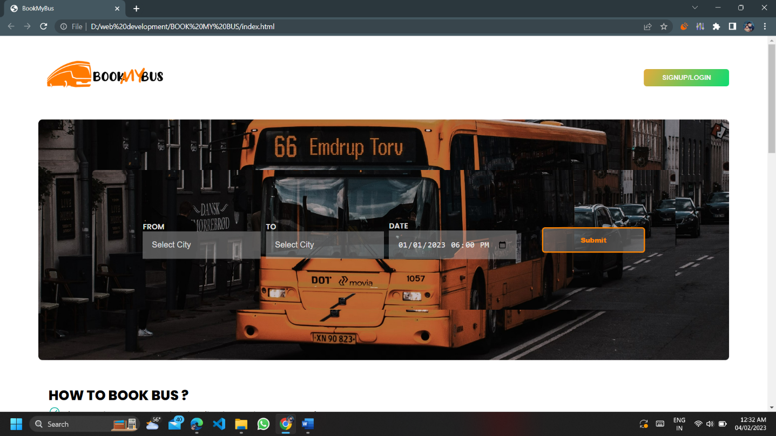

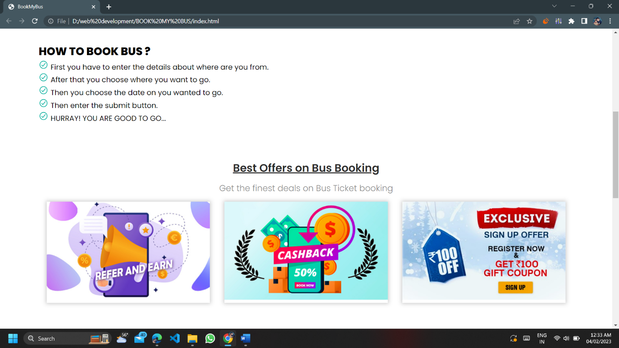

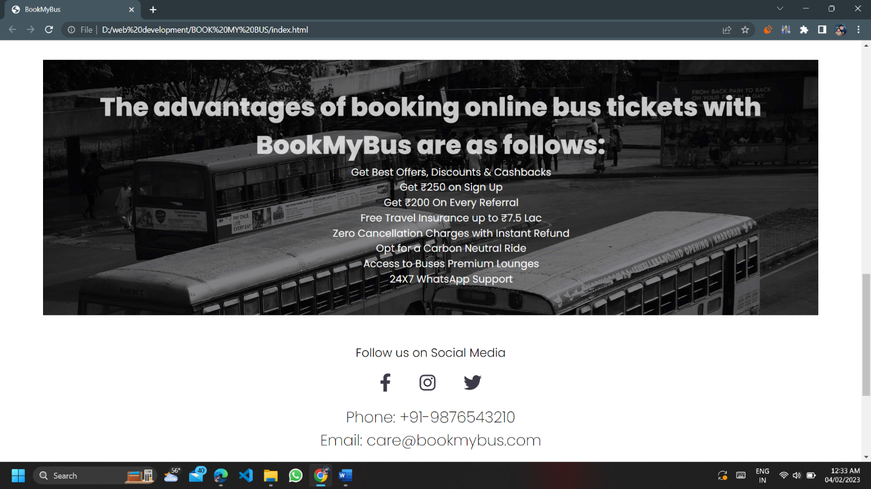

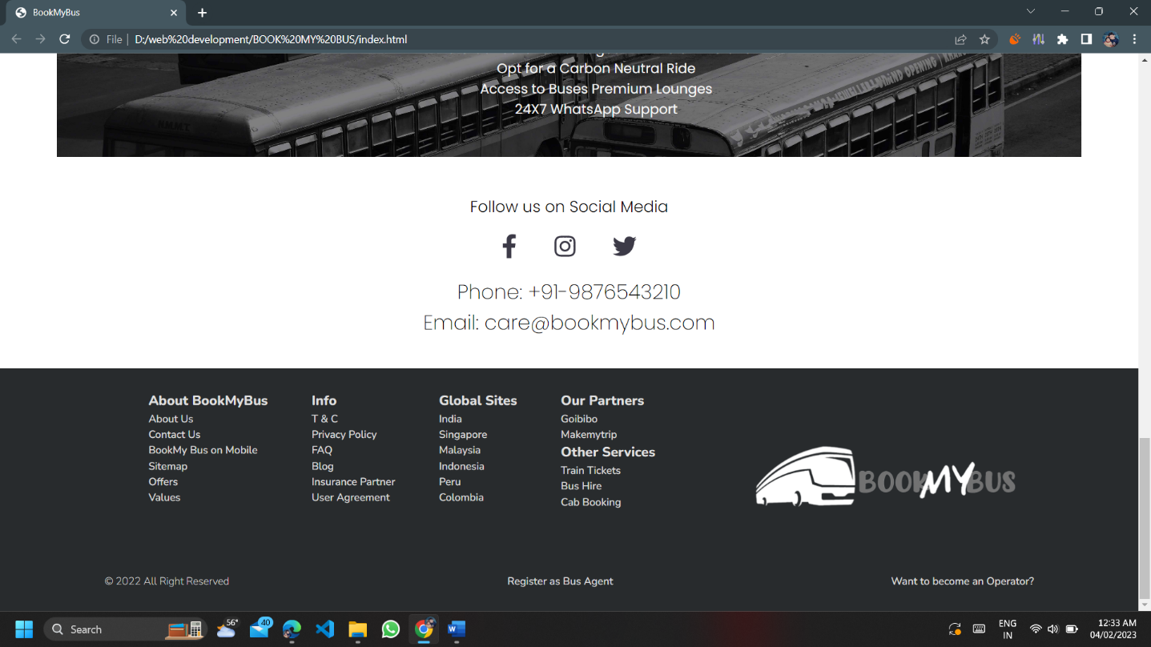

**Implementation code**

* **index.html**

<!DOCTYPE html>

<html>

<head>

<title>BookMyBus</title>

<link rel="preconnect" href="https://fonts.googleapis.com">

<link rel="preconnect" href="https://fonts.gstatic.com" crossorigin>

<link href="https://fonts.googleapis.com/css2?family=Poppins:wght@200;300;400;600;800;900&display=swap" rel="stylesheet">

<link rel="preconnect" href="https://fonts.googleapis.com">

<link rel="preconnect" href="https://fonts.gstatic.com" crossorigin>

<link href="https://fonts.googleapis.com/css2?family=Nunito:wght@200;500;600;800&family=Poppins:wght@200;300;400;600;800;900&display=swap" rel="stylesheet">

<style type="text/css">

*{

box-sizing: border-box;

padding: 0;

margin: 0;

}

html{

font-size: 18px;

-webkit-text-size-adjust: 100%;

scroll-behavior: smooth;

}

body{

font-family: 'poppins', sans-serif;

line-height: 1.5;

}

h1{

font-weight: 700;

}

h2{

font-weight: 600;

}

h3{

font-weight: 300;

}

h3.social{

font-weight: 500;

}

h4{

font-size: 2.5rem;

}

::placeholder{

color: rgb(224, 224, 224);

}

.main{

display: flex;

justify-content: space-between;

align-items:center;

gap: 30rem;

}

.form{

background-image: url(images/bus\ bg.jpg);

background-size: 100%;;

background-repeat: no-repeat;

border-radius: 8px;

border: none;

display: flex;

gap: 10px;

justify-content: center;

align-items: center;

background-position: center;

padding: 100px;

}

.todo{

display: grid;

grid-template-columns: 1fr 1fr 1fr;

gap: 2rem;

}

.off{

box-shadow: 0 0 10px 2px #2e2d2d3f;

transition: .5s;

}

.off:hover{

transform: scale(1.1);

z-index: 2;

}

img{

max-width: 100%;

}

.bus1{

width: 40%;

}

.container{

width: 90%;

margin: 0 auto;

}

form label{

color: rgb(226, 226, 226);

display: block;

text-transform: uppercase;

text-align: start;

font-size: 15px;

font-weight: 600;

margin-bottom: -.15rem;

}

form input{

background-color: #bbbbbb6f;

border: none;

padding: 1rem;

width: 100%;

color: #eaeaea;

font-weight: 400;

font-size: .90rem;

}

form input:focus{

outline: none;

background-color: #363636a1;

}

form button{

width: 100%;

cursor: pointer;

}

.btn{

background-image: linear-gradient(120deg, rgb(228, 172, 60), rgb(14, 220, 113));

border: none;

border-radius: 6px;

color: whitesmoke;

padding: .5rem 2rem;

font-weight: 600;

}

.btn:hover{

background-image: none;

color: rgb(78, 78, 78);

border: 1px solid rgb(78, 78, 78);

cursor: pointer;

}

form .btn{

background-color: transparent;

border: 3px solid #ff8400;

color: #ff8400;

padding: .75rem 3rem;

font-weight: 800;

margin-left: 40px;

}

form .btn:hover{

background-image: none;

background-color: #272727c0;

border:3px solid #272727c0;

color: white;

}

.footer-row{

display: flex;

justify-content: space-evenly;

min-width: 1000px;

max-width: 1300px;

margin: 0 auto;

overflow: hidden;

padding: 30px;

}

footer{

background-color: #282b2d;

bottom: 0;

width: 100%;

clear: both;

font-size: 14px;

font-weight: 200;

/* color: #e7e7e7; */

}

.img-cont{

width: 100%;

transition: 1s;

}

#footersec{

font-family: 'Nunito';

}

.contact{

font-size: 1.5rem;

font-weight: 200;

letter-spacing: -1;

}

.contact-info{

text-align: center;

padding: 40px;

}

.social{

list-style: none;

display: flex;

justify-content: center;

gap: 50px;

margin-top: 1.2rem;

margin-bottom: 1rem;

}

a.rdc-footer-links{

display: flex;

flex-direction: column;

color: #e7e7e7ed;

font-weight: 600;

text-decoration: none;

font-weight: 500;

}

a.rdc-footer-links:hover{

color:rgba(168, 168, 168, 0.792);

}

.dib{

color: #dedede;

font-size: 1rem;

font-weight: 700;

/* display: flex; */

}

.rights{

color: #e7e7e7ed;

}

.last-line{

display: flex;

/* flex-wrap: 100px; */

justify-content: space-between;

gap: 100px;

}

.dib-foot-wrapper{

display: flex;

justify-content: space-evenly;

}

.links-bus{

display: grid;

grid-template-columns: 2fr 1fr;

gap: 50px;

}

.advantages{

background-image: url(images/about.jpg);

background-size: 100% ;

color: #ffffffc5;

text-align: center;

margin-top: 30px;

margin-bottom: 10px;

padding: 50px;

}

.adv{

color: #fffffff0;

list-style: none;

text-align: center;

padding-left: 4rem;

}

.offer{

text-align: center;

padding: 40px;

}

.offer h2{

margin-bottom: .75rem;

color: #000000d5;

}

.offer h3{

margin-bottom: 1rem;

color: #6c6c6cd0;

}

.how{

text-align: start;

list-style-image: url(images/green-checkmark.svg);

list-style-position: inside;

padding: 50px 20px;

}

#submit{

background-image: linear-gradient(120deg, #dddddd5f, #404040,#dddddd5f);

}

</style>

</head>

<body>

<div class="container" id="form">

<div class="main">

<div class="logo"><a href="bookmybus.html">

<img src="images/bus logo 2.png" class="bus1"></a>

</div>

<div class="options">

<a href="signup.html" target="_blank"><button class="btn">SIGNUP/LOGIN</button></a>

</div>

</div>

<section class="form">

<form action="" method="post" class="form">

<div class="from" name="from">

<label for="From">From</label>

<!-- <input type="option" name="from" id="from" placeholder="Delhi"> -->

<input type="text" id="cities1" placeholder="Select City" list="cities" autofocus>

<datalist id="cities">

<option>Meerut</option><option>Noida</option><option>Dehradun</option><option>Amritsar</option><option>Ambedkar Nagar</option><option>Amroha</option>

<option>Delhi</option><option>Baghpat</option><option>Ballia</option><option>Balrampur</option><option>Bareilly</option><option>Bijnor</option>

<option>Agartala</option><option>Firozabad</option><option>Fatehpur</option><option>Faizabad</option><option>Chandauli</option><option>Bulandshahr</option>

<option>Agra</option><option>Gautam Buddha Nagar</option><option>Ghaziabad</option><option>Ghazipur</option><option>Gonda</option><option>Chitrakoot</option>

<option>Ahemdabad</option><option>Jhansi</option><option>Jaunpur</option><option>Hathras (Mahamaya Nagar)</option><option>Hardoi</option><option>Gorakhpur</option>

<option>Aizwal</option><option>Jyotiba Phule Nagar</option><option>Kannauj</option><option>Kanpur Nagar</option><option>Lalitpur</option><option>Kaushambi</option>

<option>Ajmer</option><option>Meerut</option><option>Mathura</option><option>Mainpuri</option><option>Maharajganj</option><option>Lucknow</option>

<option>Shamli</option><option>Pratapgarh</option><option>Panchsheel Nagar district (Hapur)</option><option>Muzaffarnagar</option><option>Moradabad</option><option>Mirzapur</option>

<option>Modinagar</option><option>Sant Ravidas Nagar</option><option>Sant Kabir Nagar</option><option>Saharanpur</option><option>Rampur</option><option>Raebareli</option>

<option>Jaipur</option><option>Sitapur</option><option>Siddharthnagar</option><option>Shravasti</option><option>Shamli</option><option>Shahjahanpur</option>

<option>Jodhpur</option><option>Haryana</option><option>Varanasi</option><option>Unnao</option><option>Sultanpur</option><option>Sonbhadra</option>

<option>Udaipur</option><option>Nagpur</option><option>Nasik</option><option>Banglore</option><option>Mysore</option><option>Kolkata</option>

<option>Bhopal</option><option>Bhubaneshwar</option><option>Cuttack</option><option>Indore</option><option>Damodar Valley</option><option>Shillong</option>

<option>Surat</option><option>Kanpur</option><option>Ludhiana</option><option>Rajkot</option><option>Gwaliar</option><option>Srinagar</option>

</datalist>

</input>

</div>

<div class="to" name="to">

<label for="To">To</label>

<input type="text" id="cities1" placeholder="Select City" list="cities" autofocus></input>

</div>

<div class="date">

<label for="Date">Date</label>

<input type="datetime-local" name="date" value="2023-01-01T18:00">

</div>

<div class="submit">

<a href="signup.html"><button class="btn" id="submit">Submit</button></a>

</div>

</form></section>

<section class="how"><h1>HOW TO BOOK BUS ?</h1>

<ul class="steps">

<li>First you have to enter the details about where are you from.</li>

<li>After that you choose where you want to go.</li>

<li>Then you choose the date on you wanted to go.</li>

<li>Then enter the submit button.</li>

<li>HURRAY! YOU ARE GOOD TO GO...</li>

</ul>

</section>

<div class="offer">

<h2><u>Best Offers on Bus Booking</u></h2>

<h3>Get the finest deals on Bus Ticket booking</h3>

<div class="todo">

<div class="off"><a href=""><img src="images/refer and earn.jpg" ></a></div>

<div class="off"><a href=""><img src="images/cashback.jpg"></a></div>

<div class="off"><a href=""><img src="images/signup.jpeg"></a></div>

</div>

</div>

<div class="advantages">

<h4>The advantages of booking online bus tickets with BookMyBus are as follows:</h4>

<ul class="adv">

<li>Get Best Offers, Discounts & Cashbacks</li>

<li>Get ₹250 on Sign Up</li>

<li>Get ₹200 On Every Referral</li>

<li>Free Travel Insurance up to ₹7.5 Lac</li>

<li>Zero Cancellation Charges with Instant Refund</li>

<li>Opt for a Carbon Neutral Ride</li>

<li>Access to Buses Premium Lounges</li>

<li>24X7 WhatsApp Support</li>

</ul>

</div></div>

<section class="contact-info">

<div class="social-info">

<h3 class="media-icons">Follow us on Social Media</h3>

<ul class="social">

<li><a href="https://www.facebook.com/login.php" target="_blank"><img src="images\icon-facebook.svg"></a></li>

<li><a href="https://www.instagram.com/" target="_blank"><img src="images\icon-instagram.svg"></a></li>

<li><a href="https://twitter.com/i/flow/login" target="_blank"><img src="images\icon-twitter.svg"></a></li>

</ul>

<div class="contact">

Phone: +91-9876543210

<p>Email: care@bookmybus.com</p>

</div>

</div>

</section>

<section id="footersec">

<footer>

<div class="footer-row">

<div class="clearfix rest1 promotion main-body animate">

<div class="links-bus">

<div class="dib-foot-wrapper">

<div class="row fl">

<div class="dib">

About BookMyBus

</div>

<a class="rdc-footer-links" href="" target="_blank">About Us</a>

<a class="rdc-footer-links" href="" target="_blank">Contact Us</a>

<a class="rdc-footer-links" href="" target="_blank">BookMy Bus on Mobile</a>

<a class="rdc-footer-links" href="" target="_blank">Sitemap</a>

<a class="rdc-footer-links" href="" target="_blank">Offers</a>

<a class="rdc-footer-links" href="" target="_blank">Values</a>

</div>

<div class="row fl">

<div class="dib">

Info

</div>

<a class="rdc-footer-links" href="" target="_blank">T &amp; C</a>

<a class="rdc-footer-links" href="" target="_blank">Privacy Policy</a>

<a class="rdc-footer-links" href="" target="_blank">FAQ</a>

<a class="rdc-footer-links" href="" target="_blank">Blog</a>

<a class="rdc-footer-links" href="" target="_blank">Insurance Partner</a>

<a class="rdc-footer-links" href="" target="_blank">User Agreement</a>

</div>

<div class="row fl">

<div class="dib">

Global Sites

</div>

<a class="rdc-footer-links" href="http://127.0.0.1:5500/bookmybus.html" target="_blank">India</a>

<a class="rdc-footer-links" href="" target="_blank">Singapore</a>

<a class="rdc-footer-links" href="" target="_blank">Malaysia</a>

<a class="rdc-footer-links" href="" target="_blank">Indonesia</a>

<a class="rdc-footer-links" href="" target="_blank">Peru</a>

<a class="rdc-footer-links" href="" target="_blank">Colombia</a>

</div>

<div class="row fl">

<div class="dib">

Our Partners

</div>

<a class="rdc-footer-links" href="https://www.goibibo.com/" target="_blank">Goibibo</a>

<a class="rdc-footer-links" href="https://www.makemytrip.com/" target="_blank">Makemytrip</a>

<div class="dib">

Other Services

</div>

<a class="rdc-footer-links" href="https://www.irctc.co.in/nget/train-search" target="_blank">Train Tickets</a>

<a class="rdc-footer-links" href="https://www.redbus.in/bushire/" target="_blank">Bus Hire</a>

<a class="rdc-footer-links" href="https://www.olacabs.com/" target="_blank">Cab Booking</a>

</div>

</div>

<div class="rights-cont fr">

<div class="img-cont">

<a href="#form"><img src="images/bus logo 1.png"></a>

</div>

</div>

</div>

<div class="last-line">

<p class="rights">&copy; 2022 All Right Reserved</p>

<a class="rdc-footer-links" href="">Register as Bus Agent</a>

<a class="rdc-footer-links" href="">Want to become an Operator?</a>

</div>

</div>

</div>

</footer>

</section>

</body>

</html>

* **signup.html**

<!DOCTYPE html>

<html lang="en">

<head>

<meta charset="UTF-8">

<meta http-equiv="X-UA-Compatible" content="IE=edge">

<meta name="viewport" content="width=device-width, initial-scale=1.0">

<title>Login or Signup</title>

<link rel="stylesheet" href="styles.css">

<style>

@import url('https://fonts.googleapis.com/css2?family=Poppins&display=swap');

* {

box-sizing: border-box;

}

body {

margin: 0;

font-family: poppins, Arial, Helvetica, sans-serif;

font-size: 16px;

font-weight: 400;

color: #e8e8e8;

}

.wrapper {

margin: 0 auto;

width: 100%;

max-width: 1140px;

min-height: 100vh;

display: flex;

align-items: center;

justify-content: center;

flex-direction: column;

}

.container {

position: relative;

width: 100%;

max-width: 600px;

height: auto;

display: flex;

background-image: url(images/about.jpg);

background-size: 150%;

box-shadow: 0 0 5px #414141;

}

.login .col-left,

.login .col-right {

padding: 30px;

display: flex;

}

.login .col-left {

width: 60%;

clip-path: polygon(0 0, 0% 100%, 100% 0);

background: #ff8400;

}

.login .col-right {

padding: 60px 30px;

width: 50%;

margin-left: -10%;

}

@media(max-width: 575px) {

.login .container {

flex-direction: column;

box-shadow: none;

}

.login .col-left,

.login .col-right {

width: 100%;

margin: 0;

clip-path: none;

}

.login .col-right {

padding: 30px;

}

}

.login .login-text {

position: relative;

width: 100%;

color: #ffffff;

}

.login .login-text h2 {

margin: 0 0 15px 0;

font-size: 30px;

font-weight: 700;

}

.login .login-text p {

margin: 0 0 20px 0;

font-size: 16px;

font-weight: 500;

line-height: 22px;

}

.login .login-text .btn {

display: inline-block;

font-family: poppins;

padding: 7px 20px;

font-size: 16px;

letter-spacing: 1px;

text-decoration: none;

border-radius: 30px;

color: #ffffff;

outline: none;

border: 1px solid #cccccc;

box-shadow: inset 0 0 0 0 #cccccc;

transition: .3s;

}

.login .login-text .btn:hover {

color: #ff8400;

box-shadow: inset 150px 0 0 0 #ffffff;

}

.login .login-form {

position: relative;

width: 100%;

}

.login .login-form h2 {

margin: 0 0 15px 0;

font-size: 22px;

font-weight: 700;

}

.login .login-form p {

margin: 0 0 10px 0;

text-align: left;

color: #e8e8e8;

font-size: 15px;

}

.login .login-form p:last-child {

margin: 0;

padding-top: 3px;

}

.login .login-form p a {

color: #ff8400;

font-size: 14px;

text-decoration: none;

}

.login .login-form label {

display: block;

width: 100%;

margin-bottom: 2px;

letter-spacing: .5px;

}

.login .login-form p:last-child label {

width: 60%;

float: left;

}

.login .login-form label span {

color: #ff8400;

padding-left: 2px;

}

.login .login-form input {

display: block;

width: 100%;

height: 35px;

padding: 0 10px;

outline: none;

border: 1px solid #cccccc;

border-radius: 30px;

}

.login .login-form input:focus {

border-color: #ff8400;

}

.login .login-form button,

.login .login-form input[type=submit] {

display: inline-block;

width: 100%;

margin-top: 5px;

color: #ff8400;

font-family: Poppins;

font-size: 16px;

letter-spacing: 1px;

cursor: pointer;

background: transparent;

border: 1px solid #ff8400;

border-radius: 30px;

box-shadow: inset 0 0 0 0 #ff8400;

transition: .3s;

}

.login .login-form button:hover,

.login .login-form input[type=submit]:hover {

color: #ffffff;

box-shadow: inset 250px 0 0 0 #ff8400;

}

body{

background-image: url(images/bus.jpg);

background-size: 100%;

}

</style>

</head>

<body>

<div class="wrapper login">

<div class="container">

<div class="col-left">

<div class="login-text">

<h2>Welcome!</h2>

<p>Login or Create Your <br>Account For <br> Free!</p>

</div>

</div>

<div class="col-right">

<div class="login-form">

<h2>Login or Register</h2>

<form>

<p> <label>Email id/Mobile Number<span>*</span></label> <input type="text" placeholder=""> </p>

<p> <label>OTP<span>*</span></label> <input type="text" placeholder=""> </p>

<p> <a href="#">Get OTP</a> </p>

<p> <a href="index.html" target="_blank"><input type="submit" value="SIGN IN/SIGN UP"></a> </p>

</form>

</div>

</div>

</div>

</div>

</body>

</html>

**REFRENCES**

1. Learn HTML and CSS from Envoto Tuts+ on Youtube - https://youtu.be/iG2jotQo9NI

2.Take idea of Bus Booking ideology from Zingbus - https://www.zingbus.com

3. For making a Attractive login page we use code wit random website - https://www.codewithrandom.com/2021/11/30/login-and-sign-up-form-using-only-html-css-onlycodewithranom/